Notes for final submission – MSc

Chapter 4: Analysis  
20 pages

Chapter 5: Results and Discussions  
15 pages

Chapter 6: Conclusions and Recommendations  
3-6 pages

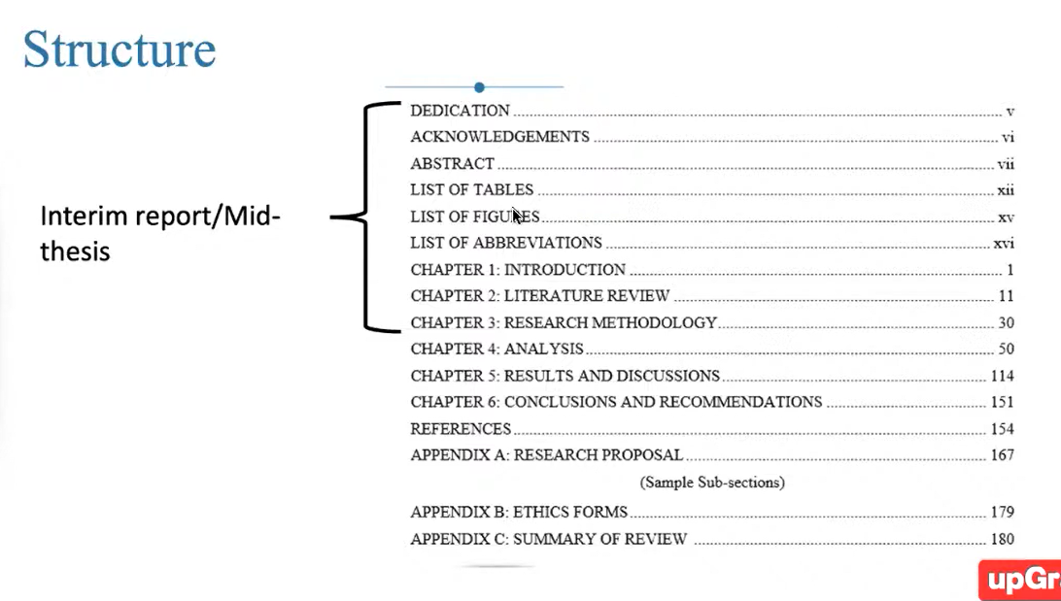

CHAPTER 4

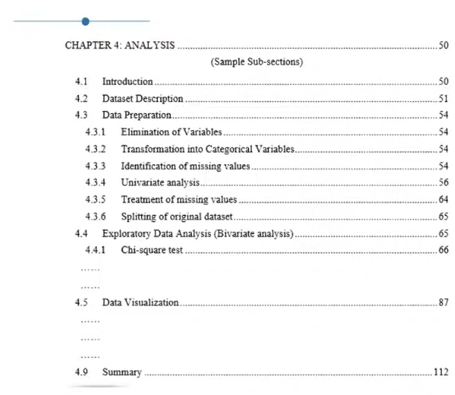

CHAPTER 5

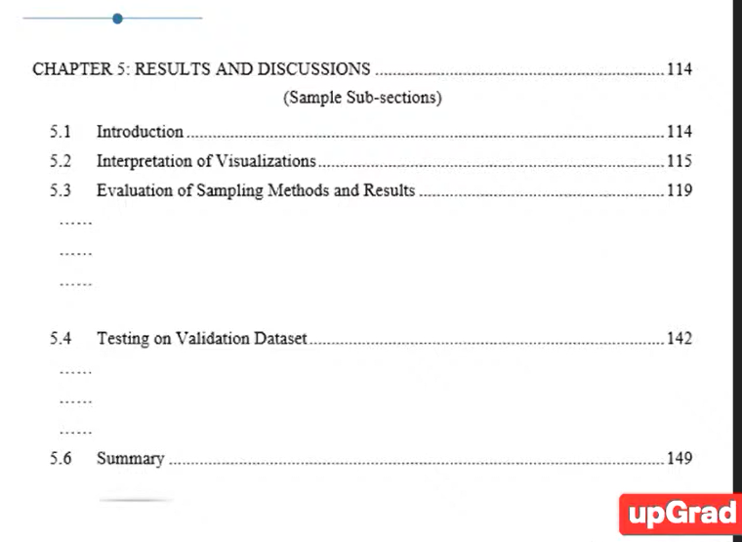

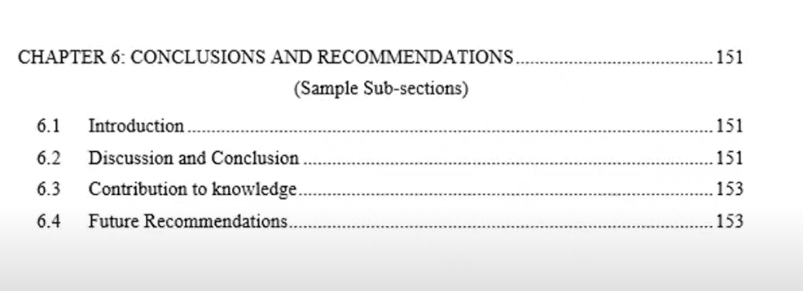

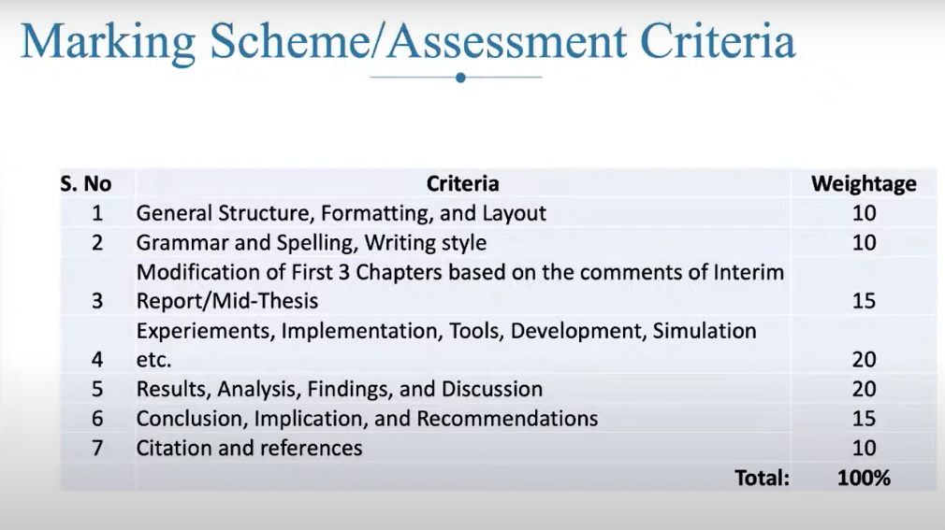

Order of writing

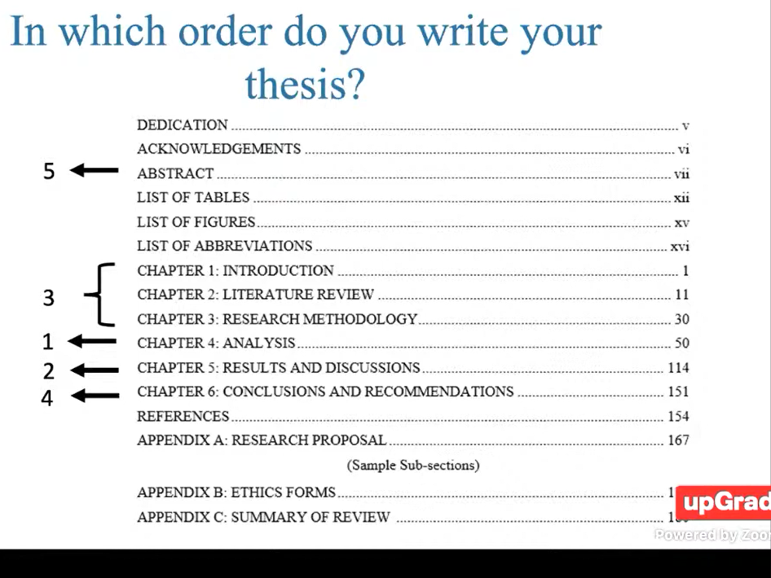

Cam studio

15 mins

Revise abstract and title after finishing thesis